
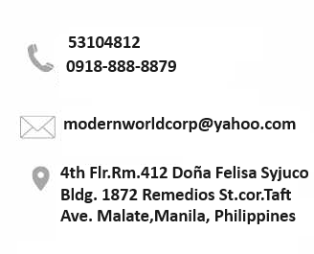

Dear Sir/Madam:

We are please to introduce our company, MODERN WORLD EXPLORATION RECRUITMENT CORP. a
Reputable and experience manpower agency dedicated to providing high-quality staffing solutions to companies across to Gulf Country and Europe.

With a proven track record of excellence in the recruitment and deployment of skilled manpower, we are
Confident in our ability to meet your company’s staffing needs effectively. Our commitment to client satisfaction,
combined with our extensive network of qualified candidates, positions us as ideal partner to support your organization’s growth and success.

We have sufficient volume of Volumes candidates from our data source in all categories from professional
to skilled workers to supply your manpower needs.

We understand that finding the right talent to support your company’s operations id crucial for success.
Our team will work closely with you to gain a thorough understanding of your staffing requirements, including
skill sets, experience levels, and cultural fit. Leveraging our extensive database of qualified candidates and
industry expertise, we will customize recruitment strategies to source and screen candidates who meet your
specific criteria.

Our rigorous selection process ensures that only the most suitable candidates are presented for your
consideration. From initial candidates sourcing and screening to onboarding and ongoing support, we offer
end-to-end manpower supply services to streamline the hiring process and maximize efficiency. Our team will handle all
aspects of recruitment, allowing you to focus on your core business activities.

We are committed delivering excellence in all aspects of our services. Our stringent quality assurance measures
and regular performance evaluations ensure that our candidates meet or exceed your expectations, delivering
value and reliability to your organization.

Our pricing structure is transparent and competitive, with no hidden fees or surprises. We believe in building
long-term partnerships based on trust and mutual benefit, and we are committed to providing cost-effective staffing
solutions that align with your budgetary requirements. We would welcome the opportunity to further discuss how
your Company can support your company’s staffing needs. Please feel free to contact us at your earliest convenience
to schedule a meeting or to address any questions you may have.


Thank for considering Modern World Exploration Recruitment Corp. as your manpower supply partners

We look forward to the possibility of working together to achieve your staffing goals and contribute to the success
of your organization.

Thank you.

MODERN WORLD EXPLORATION RECRUITMENT CORP.

(Company Profile)

DMW LIC.: 010-LB-01032024-PL
Room 412, 4th Floor, Doña Felisa Syjuco Building 1872, Remedios St. cor. Taft Ave. Malate, Manila, Philippines.

Page 1
Modern World Exploration Recruitment Corp: Company Profile

Modern World Exploration Recruitment Corp.is licensed manpower
Agency Under the Department of Migrant Workers (DMW).
with license number DMW-010-LB-01032024-PL.
Unique Selling Proposition (USP)
Though we are a new company, our core team were already in this field of business for more than a decade. Gaining connections with a lot of trusted employers and knowledge in handling applicant related problems

"Our Legal Responsibility"
We conduct our business by objectively and legally providing job opportunity to our fellow Filipino in compliance and in accordance with the laws, rules and regulations in all countries involved in our business operation.

Address: Room 412 4th Floor Doña Felisa Syjuco Building
1982, Remedios St. cor. Taft Ave. Malate, Manila,
Philippines
Telephone: 5 310-48-12
Mobile: 0918-888-8879 / 09294887316
Email: modernworldcorp@yahoo.com

Page 2
Modern World Exploration Recruitment Corp: Company Profile

Mission and Vision
'

Mission
To achieve our vision by providing the best job opportunity for our Filipino overseas workers and to provide a quality worker for our employers.
Vision
To become one of the best and trusted manpower agencies in the Philippines by utilizing our expertise and experience in recruitment.

Page 3
Modern World Exploration: Company Profile

Page 3
Modern World Exploration: Company Profile

Mary Ann F. Malaluan
Atty. Jerry S. Dela Cruz
VIOLETA C. JACOB

Treasurer

Chairwoman/President

Corporate Secretary

Vacant
Recruitment Head
Ethelrene V. Magdamit
Accounting Clerk

Vacant
Marketing Manager

MAY J. MARTINEZ
Welfare Desk Officer

Leticia J. Telada
Recruitment Assistant
Contantino C. Nalupa
Recruitment Staff
Josephine N. Tadoy
Account Officer
Roderick O. Reyes
Embassy/DMW
Liaison Officer

Page 4
Modern World Exploration: Company Profile

Recruitment

This is a process of identifying, attracting, interviewing, selecting, and hiring employees. In manpower recruitment, this is done thru various communication method such as but not limited to:
  - Social Media Platform,
  - Advertisements (newspaper, radio, tarpaulins, brochures etc.)
  - Conduct Interview (provincial LGU) thru Special Recruitment Authority (SRA)
& Job Fairs (JFA) thru the local government
  - Referrals by agents and other trusted persons.

Applicant Screening

Through this process, we will be able asses the applicants’ skills and provide them a job that fits them and on the other hand we provide the right applicants to our employers.

Page 5
Modern World Exploration: Company Profile

Legal Document Processing

Once the applicants are deemed qualified, we are going to help them with all the requirement such as:
  - Medical examination with accredited clinics.
  - Training Certificate (TESDA) (NC II) for Skilled workers; Engineers;(Medical staffing/Nurses, like Mumaris; data flow; prometric, and other documents to be required for:
  - Visa Stamping, OEC/exit pass documents, PDOS, OWWA.
  - Confirmed flight tickets.

Applicant Overseas Assistance

We care for our people, should there be any problem abroad involving our applicants, we are going to provide guidance and assistance subject to our legal responsibilities under the Department of Migrant Workers (DMW) and other government bodies concerned.

Page 6
Modern World Exploration: Company Profile

Summary of Basic Terms:

  - Summary of basic terms governing our deployment of workers and payment of our service fees, these terms are by no means final and subject to the provisions of the applicable laws, rules and regulations. These terms may be modified or revised depending on the final agreement mutually arrived at by Modern World Exploration and the client/employer.

Deployment of Manpower:

- Modern World Exploration Recruitment Corp. will deploy the worker to the client within a maximum period of twenty (20) to forty-five (45) days, provided the following have been completed and/or provided.
- Job Order duly approved by the Department of Migrant Workers (DMW)
- Duly approved and stamped working visa (host country)
- DMW approval of the Overseas Employment Certificate (OEC);
- Provision by the client of the plane ticket for the worker.

Required Documents from the Client/Employer:

- Verified Recruitment Agreement; Special Power of Attorney; Manpower Request Employment Contract; Commercial Registration duly attested by nearest Philippine Overseas Labor Office (POLO); or Migrant Workers Office (MWO) in the host country.
- Approved Working Visa from employer.
- Issuance of the plane ticket for each hired worker or equivalent amount of

Page 7
Modern World Exploration: Company Profile

one-way ticket (MANILA-DESTINATION);

OUR CLIENT:

MODERN WORLD (CLIENT)
ESTABLISHMENT WADI AL-GIAL FOR DECORATION (SAUDI ARABIA)
SULAIMAN IBRAHIM AL RAWAF ESTABLISHMENT
LUTOS FAMILY RESTAURANT & CATERING SERVICES (BRUNEI)
SAUDI GOLD FACTORY COMPANY
AL KAWKAB AL BAEED PROJECT MANAGEMENT (UAE)
PSL ENTERTAINMENT (UAE)
MADAEN STAR GROUP
METO DEVELOPMENT GROUP (MARSHAL ISLAND)
KONIG AGENCY S.R.O. (CZECH REPUBLIC)
WISHAH ALTAWN FOR SECURITY GROUP (SAUDI ARABIA)

BAB AL KHAIR (Restaurant & Hotel) Sultanate of Oman
FEEL PINK BEAUTY SALON COMPANY (UAE)


Page 8
Modern World Exploration: Company Profile

RECRUITMENT PROCESS FLOW DIAGRAM

Applicant Files, C.V & Information Sheet
Submitted Information Verified/Checked
Preliminary Interview
Final Interview
Accreditation of Foreign Employers
Actual Trade Testing as Required
Pre- Qualified/ Referred
Medical & Psychological Examinations
Passporting & Documentation
(OEC & Visa Stamping)

Pre-Departure Orientations
Airline Booking
Departure

Page 9
Modern World Exploration

Page 8
Modern World Exploration: Company Profile
CATEGORY | JOB TITLE
ENGINEERING PROFESSIONALS | ARCHITECTS
ENGINEERING PROFESSIONALS | CHEMICAL ENGINEERS
ENGINEERING PROFESSIONALS | COMPUTER ENGINEERS
ENGINEERING PROFESSIONALS | ELECTRICAL ENGINEERS
ENGINEERING PROFESSIONALS | ELECTRONICS & COMMUNICATION ENGINEERS
ENGINEERING PROFESSIONALS | INDUSTRIAL ENGINEERS
ENGINEERING PROFESSIONALS | MECHANICAL ENGINEERS
ENGINEERING PROFESSIONALS | SAFETY ENGINEERS
ENGINEERING PROFESSIONALS | STRUCTURAL ENGINEERS
ENGINEERING PROFESSIONALS | SURVEYORS
OTHER PROFESSIONALS | ACCOUNTANTS
OTHER PROFESSIONALS | DENTISTS
OTHER PROFESSIONALS | MEDICAL TECHNOLOGISTS
OTHER PROFESSIONALS | NURSES
OTHER PROFESSIONALS | PHYSICIANS
OTHER PROFESSIONALS | CAREGIVER/ MASSAGE THARAPIST
OTHER PROFESSIONALS | HOTEL RESTAURANT MANAGER
OTHER PROFESSIONALS | MIDWIVES
OTHER PROFESSIONALS | MEDICAL STAFFS
OTHER PROFESSIONALS | INFORMATION TECHNOLOGY
COMMUNICATION TECHNICIANS | COMPUTER TECHNICIANS
COMMUNICATION TECHNICIANS | CABLE JOINTERS/SPLICERS
COMMUNICATION TECHNICIANS | ELECTRONICS TECHNICIANS
COMMUNICATION TECHNICIANS | TELEPHONE TECHNICIANS
SKILLED WORKERS | ALUMINUM INSTALLERS/FABRICATORS
SKILLED WORKERS | WELDER/PLUMBER/CARPENTRY; WAITER  Receptionist; General Cook , Cashier  Heavy Equiptment Optr. (for Road Construction)  Auto Electirican; Auto Denter;Auto Mechanic;  Bldg.Electirican; Salesman; Housekeping
AR

Page 10
Modern World Exploration

Job Destination:

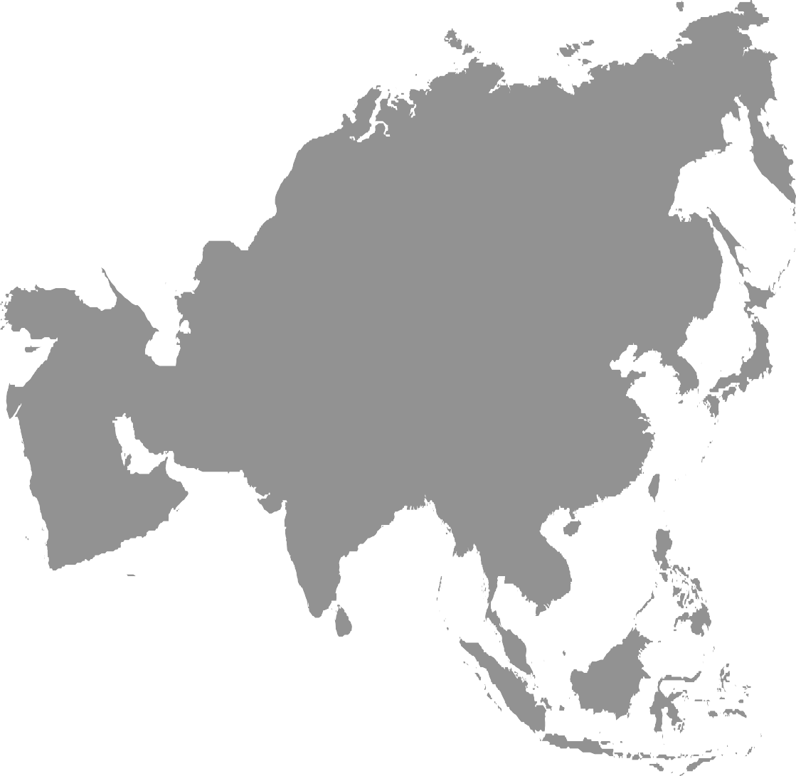

MIDDLE EAST COUNTRY: European Country:

Poland; Czech Republic

ASIA PACIFIC
Jeddah Riyadh Dammam Kuwait
Qatar
UAE

Page 11
Modern World Exploration. Company Profile

Modern World

Exploration Recruitment Corp.

DMW LIC.: 010-LB-01032024-PL

Room 412 4th Floor Doña Felisa Syjuco Building 1872, Remedios Street,cor. Taft Ave. Malate,Manila, Philippines.
Tel: 5310-48-12 Mobile No.0918-888-88-79 / 09294887316
Email Add: modernworldcorp@yahoo.com

Page 12
Modern World Exploration: Company Profile

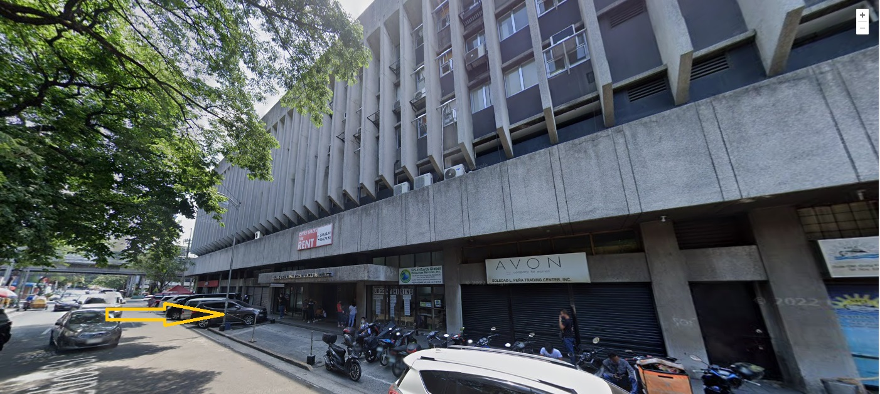

Our Office

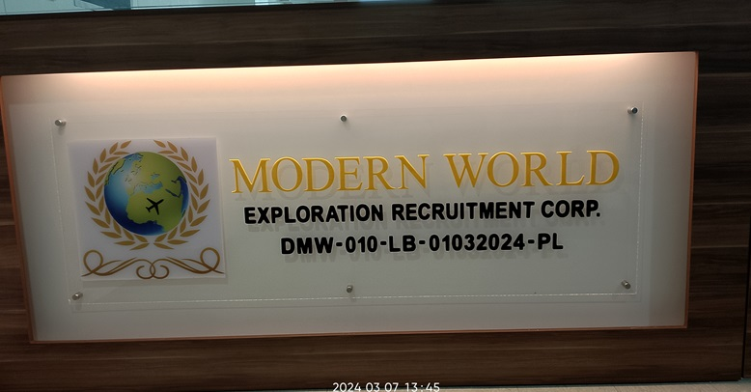

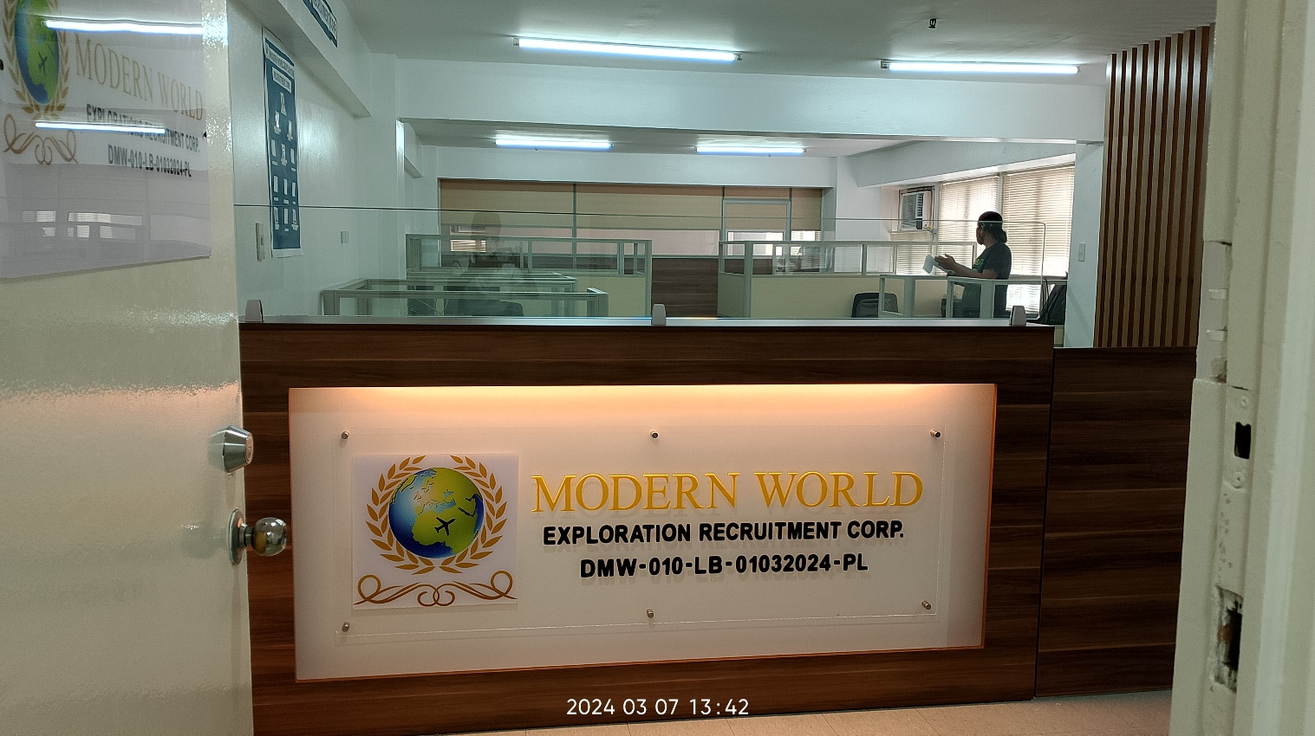

Counter Area

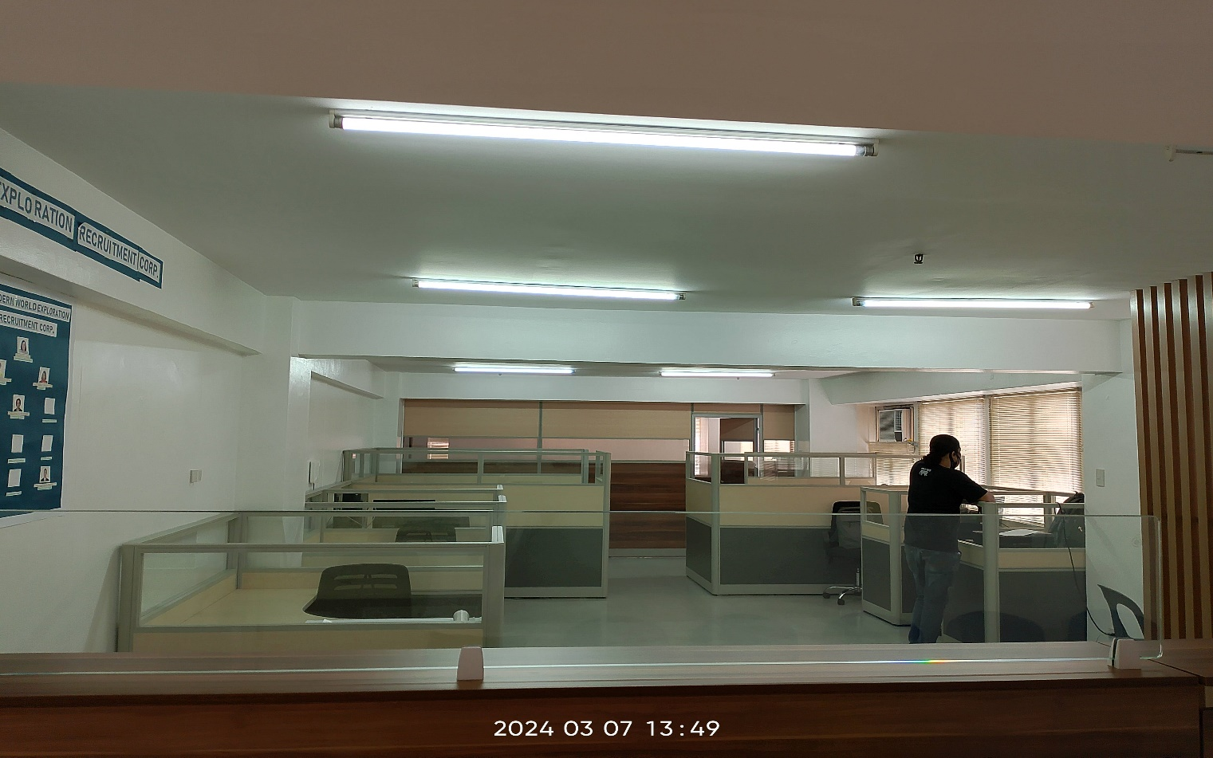

Inside of Office

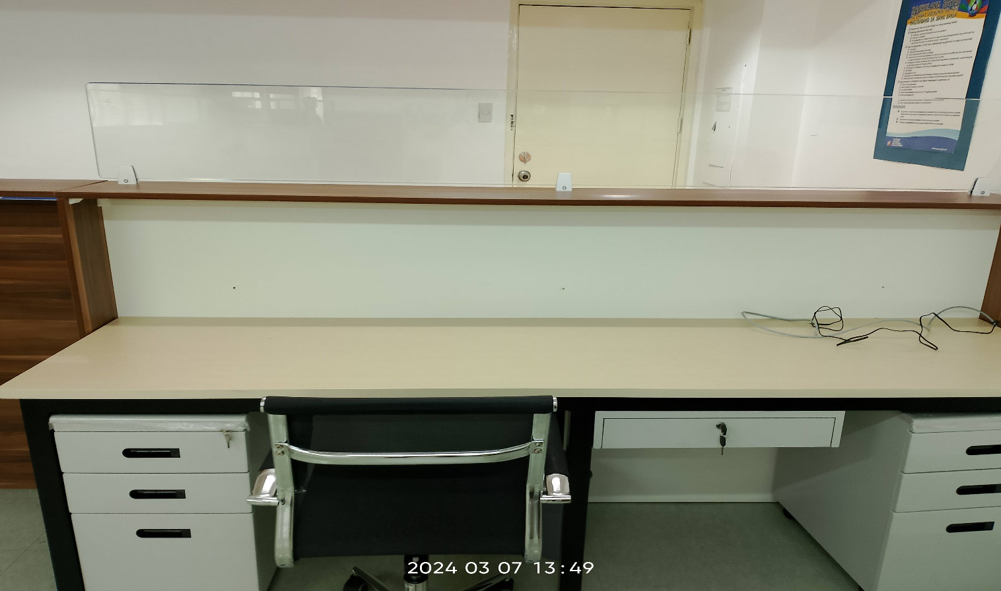

Front Desk

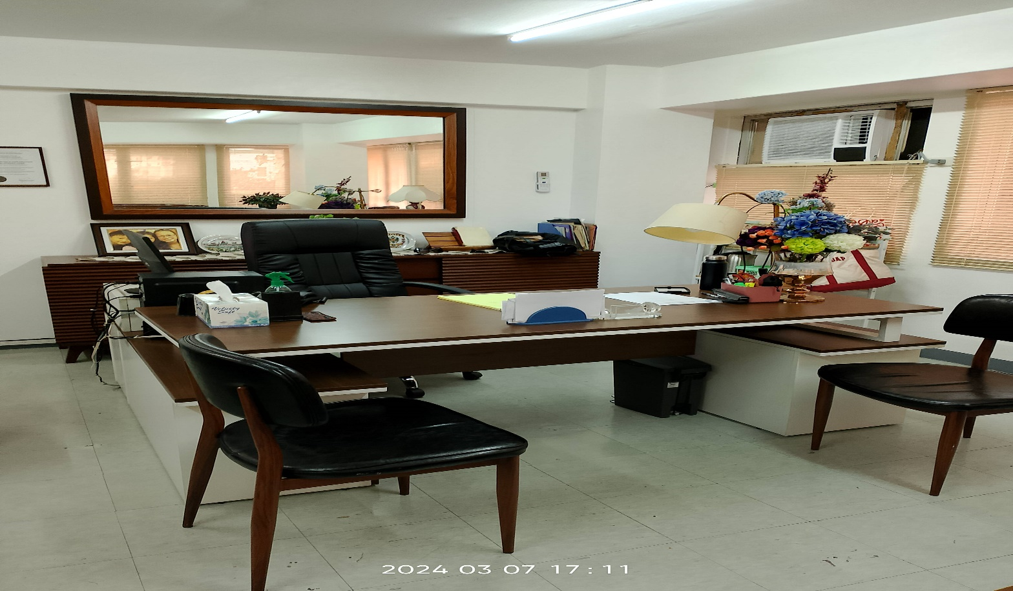

Executive Table
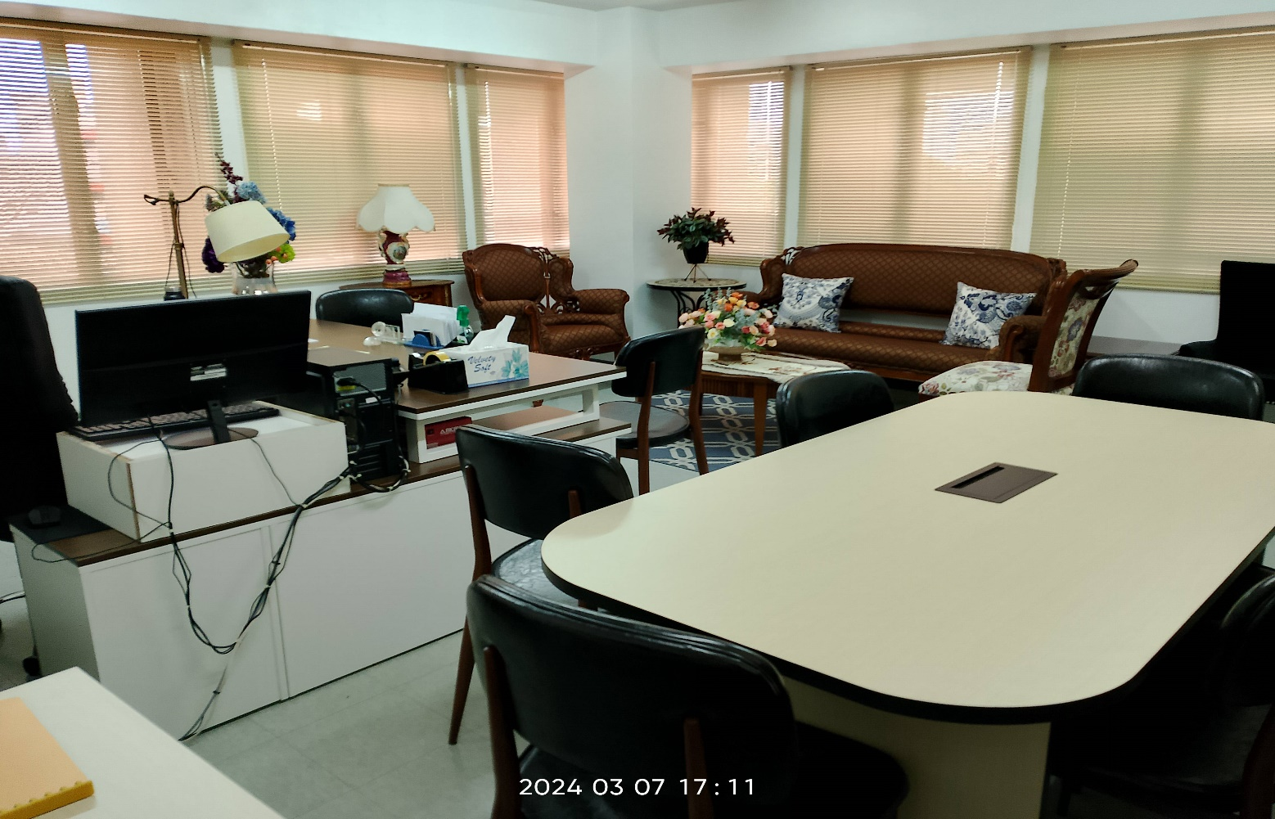

Executive Room

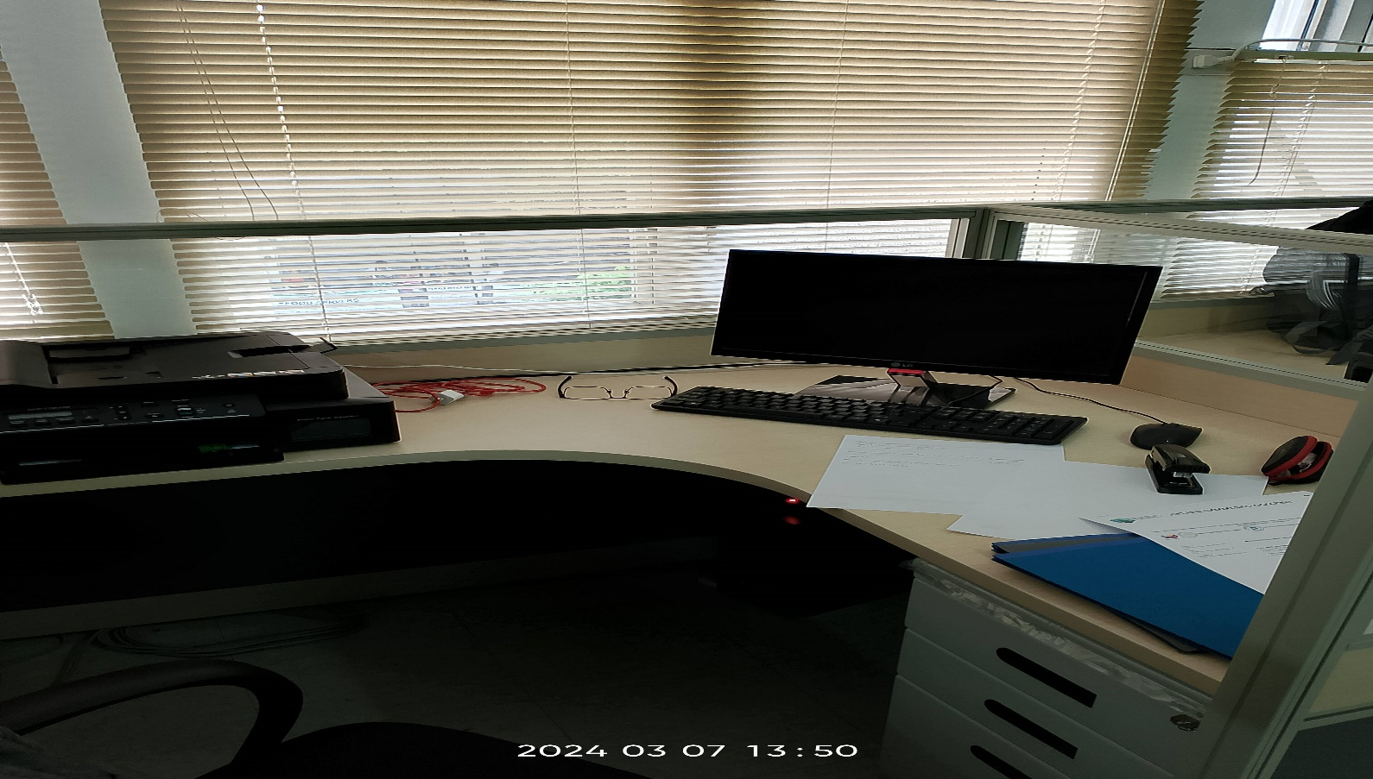

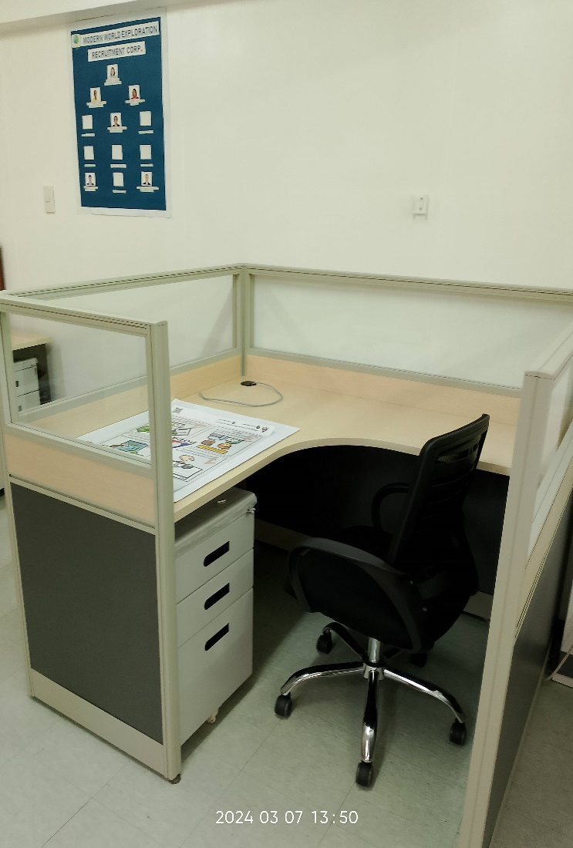
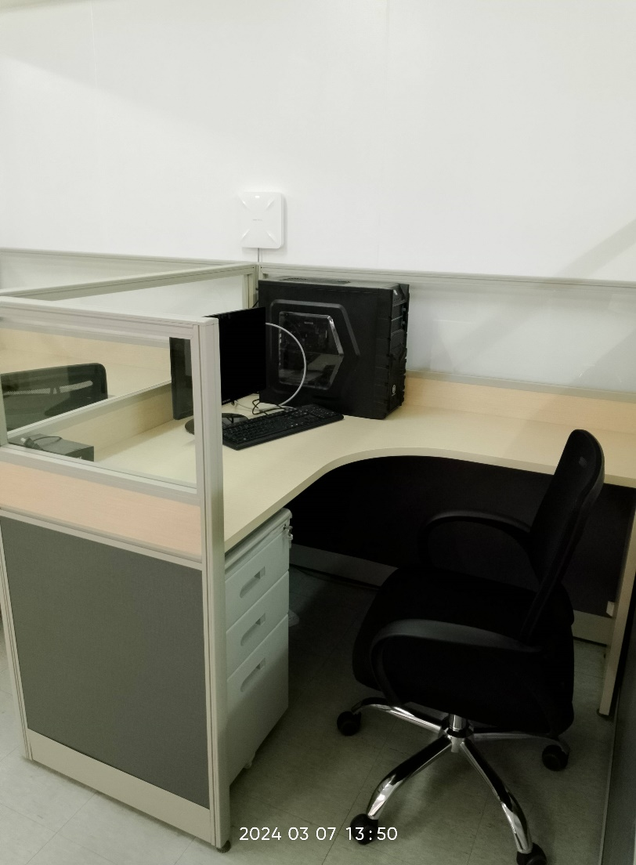

PROCESSING AREA

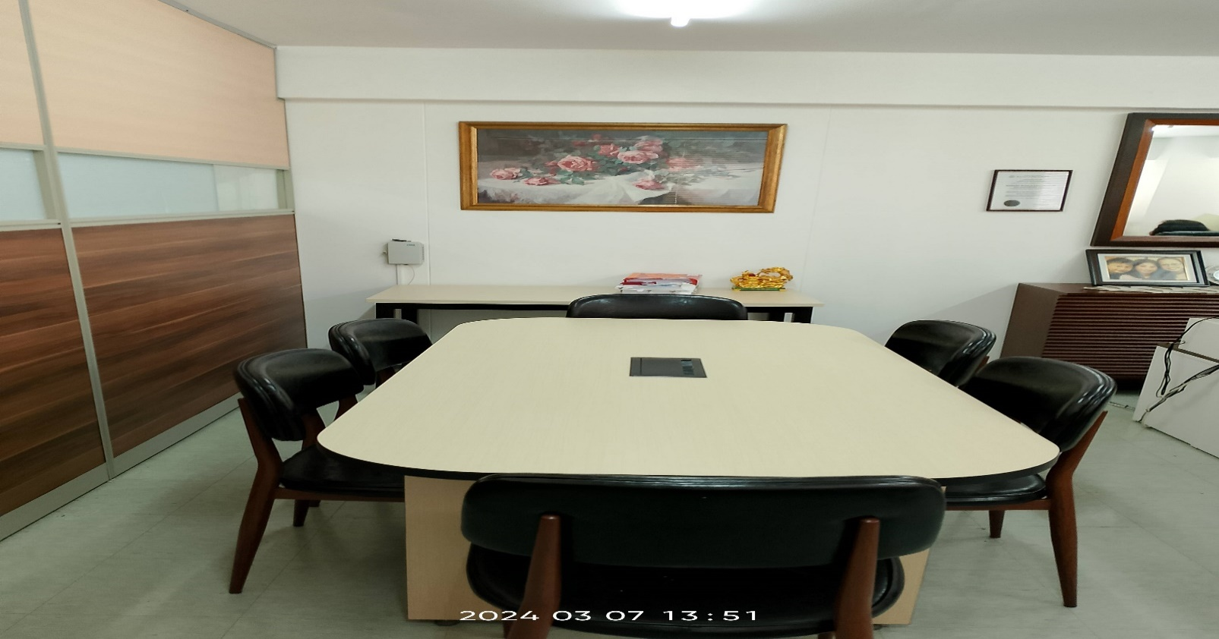

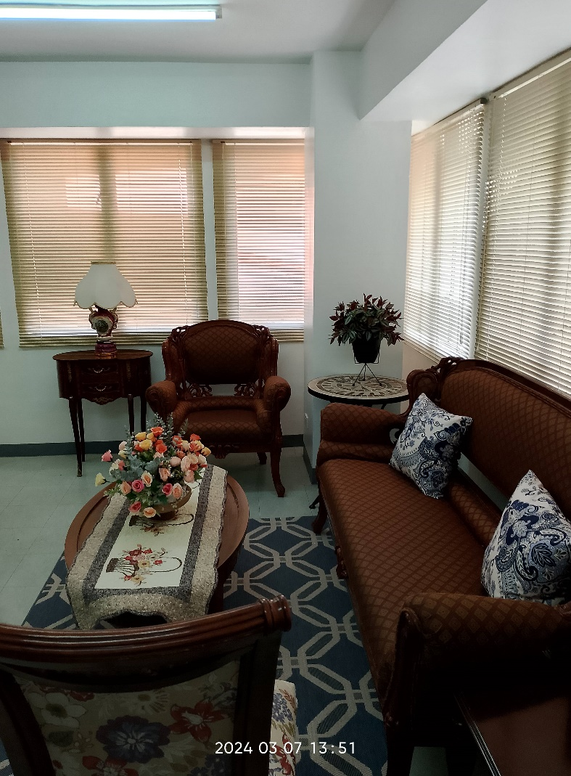
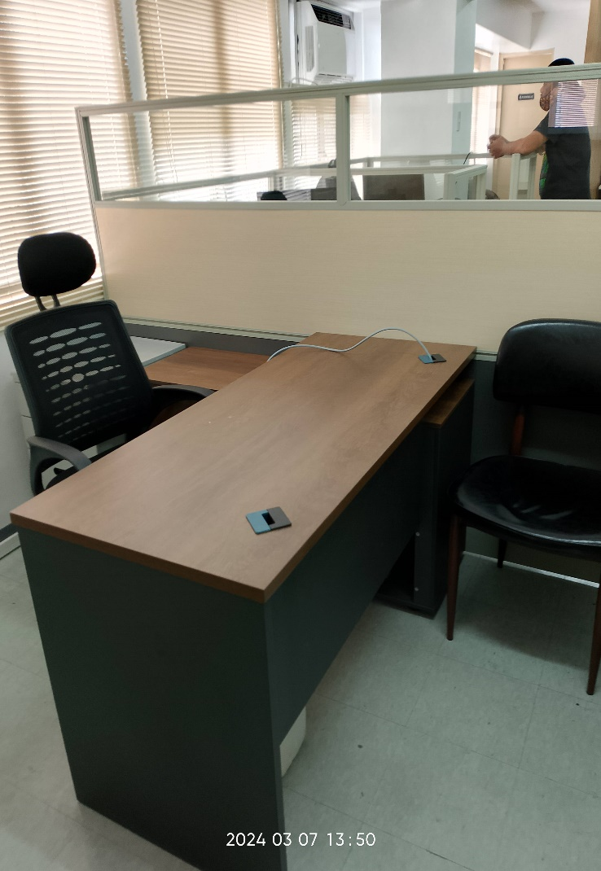
CONFERENC E TABLE

OFFICE LICENSE
